Intersections are dangerous

When the light turns green, you remove your foot from the brake and drive into the intersection. Suddenly, a vehicle from your right races through the intersection because the driver is trying to beat the light that has already turned red. It may have been a near miss, but perhaps you weren’t so lucky.
Intersections are among the most common places for accidents to occur. Studies report that about half of all motor vehicle accidents happen at intersections, and almost all of them are the result of a driver making a terrible mistake.

What goes wrong?
Even in a quiet neighborhood, chances are that there is a lot going on at any intersection. Not only might there be traffic coming from any direction, but a driver may also have to deal with children playing, pedestrians, people on bikes, directional signs, animals and other factors. Additionally, many drivers have their own distractions inside the vehicle, which increases the chances of an accident. The most common reasons why crashes occur at intersections include the following:
- Drivers not taking time to look in all directions
- Drivers making wrong predictions about the actions of another vehicle
- Drivers turning from one street to another without having a clear view in that direction
- Drivers making U-turns or other illegal or unsafe moves
- Drivers misjudging the speed of other vehicles
- Drivers eating, using a cellphone, adjusting controls within the vehicle or other distractions
- Drivers going too fast to avoid a collision
Unlike other places on the road, at an intersection, there is a greater chance for every kind of collision, from rear-end to head-on, side-swipe and T-bone. Unfortunately, not every driver realizes this. Those who fail to slow down when approaching an intersection or refuse to use their turn signals or try to beat the light place your life and the lives of other motorists in grave danger.
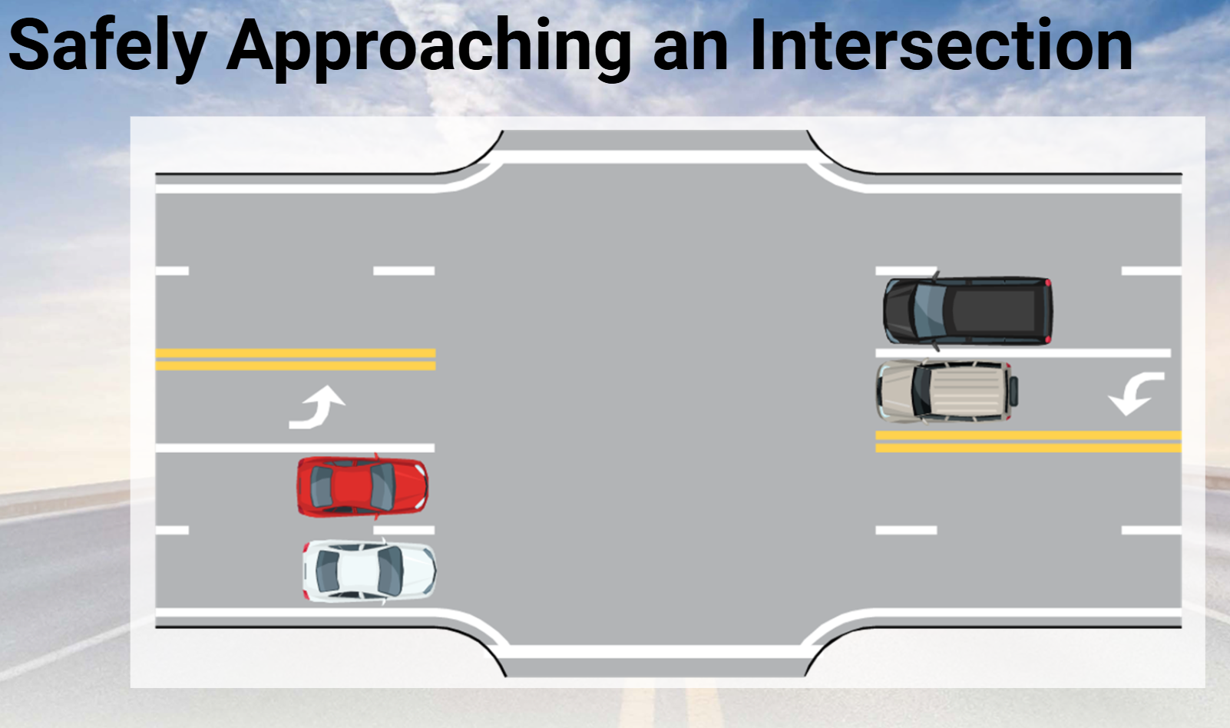

- When it comes to the right of way, the reality is no one has the right of way. Traffic regulations only state who should yield the right of way.

- 2 million crashes/yr. with over 3,000 fatalities at intersections.

- When approaching and intersection cover the brake.
  - Scan the intersection
  - Look left
  - Look right
  - Look straight ahead
  - Look left again
  - Remember the ‘what if’s”
  - What is “covering the brake”? Approaching an intersection with green light. It could save you ¾ to 1 second if somebody pulls out in front of you.

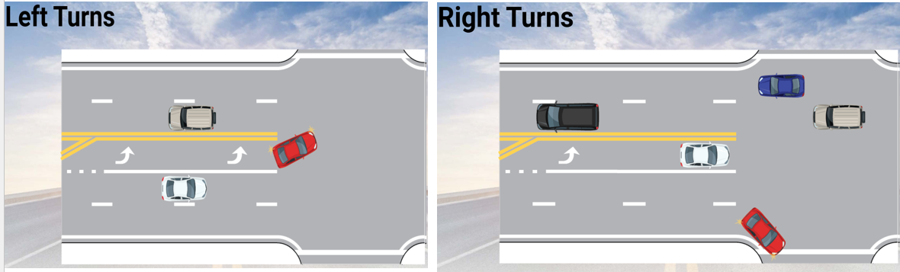
Turning is one of the basic maneuvers of driving and one of the most important. When making right turns or left turns, always remember to do the following steps:
- Signal and slow down or brake before the turn
It’s important to signal before reducing your speed, as this is how you’ll warn vehicles behind you of your intentions of turning. Remember that you must signal 100 feet before turning in residential/city driving areas and 200 feet in highway/rural areas. When making a turn at an intersection without a stop sign or red light, it is not required that you come to a complete stop, but you’ll still need to slow down to a safe speed and be aware of other cars coming from all directions.
- Scan through the turn to the center of the lane
Scan the stopping area for potential hazards such as other vehicles, pedestrians, or debris in the roadway. Then, identify the proper lane before turning and aim for the center of the lane.
- Use the hold-and-turn method with lesser turns
With the hold-and-turn (sometimes known as the pull-push-slide) steering method, your hands do not cross each other. This method is only used in situations where you are traveling around a curve.
- Use the hand-over-hand method with sharper turns
As the name suggests, your hands are going to cross each other while turning the wheel. Hand-over-hand may feel awkward at first, but it’s the proper and safest method for making a turn. By having both hands on the wheel, you are prepared to make a quick, evasive action if need be mid-turn.
- Accelerate out of the turn when safe
At the halfway point of the turn, begin accelerating gently and you’ll feel the vehicle begin to straighten itself out. Don’t let go of the wheel totally but gently hold on and allow it to move back to the centered position. Hand-over-hand method will require some practice.

